PREPARING "CAMERA-READY" MANUSCRIPTS FOR ANALES AFA
PREPARING CAMERA READY MANUSCRIPTS FOR ANALES AFA

X.X. Alfa ª, Y.Y. Beta ª, Z.Z. Gamma ^{b} *
a Institute of Applied Mathematics San Luis (IMASL) – National University of San Luis (UNSL) Luis – CONICET
Ejército de los Andes 950 – (5700) San Luis – Argentina
b Laser and Applications Research Centre CEILAP (CITEDEF-CONICET)
Juan Bautista de La Salle 4397 – (B1603ALO) Villa Martelli – Prov. Buenos Aires – Argentina
Received: xx/xx/xx; accepted: xx/xx/xx
En este trabajo se presentan las indicaciones para confeccionar las contribuciones para ANALES AFA en versión “camera-ready”.
Palabras clave: preparación, manuscritos, publicación.

This paper presents the instructions for “camera-ready” contributions to ANALES AFA.
Keywords: making, papers, publishing.

I. INTRODUCTION
These instructions are intended to assist authors wishing to publish in ANALES AFA to prepare their manuscripts for direct photo-offset reproduction. Papers will not undergo any further reduction. This process enables them to be published in the form their authors prefer, gives the journal uniformity and results in more efficient, economical and faster printing.
This document is itself an example of how papers will appear in their final form for publication. Articles must be written in SPANISH, ENGLISH or PORTUGUESE with the title, abstract and key words in SPANISH or PORTUGUESE as well as ENGLISH; the latter is for purposes of inclusion in international citation systems.
II. METHODS
Instructions for writing
Manuscripts must fit in a rectangle 17 x 25.2 cm2, as shown in Fig 1, in DIN A4 paper format (21 x 29.7 cm), while respecting the margins indicated.
Authors are requested to produce their manuscripts using a common word processor. Do not submit hard copies of electronic documents. Papers should be submitted in PDF format (for review), and the final corrected and approved version will be sent in both PDF and .DOC, by email only to analesafaba@gmail.com or analesafatan@gmail.com.
This document has been written in WORD and includes the specifications for all the necessary styles; it can therefore be used as a template and overwritten. Please, DO NOT INCLUDE page numbering.
Typefaces and line spacing
All manuscripts must be single-spaced, with spacing automatically increased for sub-indexes and super-indexes. They must be written in Times New Roman font, in two-column format.
Table 1 shows the font sizes, paragraph formats and section separations. For example, the standard paragraph requires an indentation of 1 cm and a 6 point space between paragraphs. Remember that 1 point = 1 pt. ≅ 0.25 mm. The list of styles in Table 1 is also included in the file associated with this document.
Illustrative material
Figures and tables must be inserted in the text, at the point where the author considers it most appropriate. Captions for figures must be included below each figure, while table headings must appear directly above the table.
The width of figures or tables can extend across both columns.

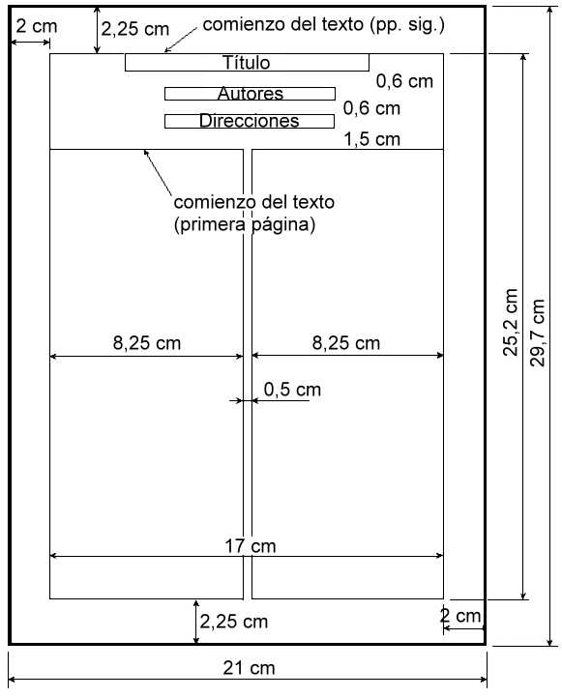
Figure 1. Recommended page format.

Format of equations
Equations must be centred in the column and numbered consecutively, with the number in brackets, right-aligned. When citing equations, place them in line with the text; for example, (see Eq. 4).
Format of references
For references, APS journal format must be followed. It is therefore necessary to use superscripts (raised numbers) for reference marks¹ and to create a single list in order of citation at the end of the article. To avoid confusion with other reference marks, use different symbols for the latter. The list of references should include titles in the case of articles, books, monographs, theses, etc.² . The abbreviation of journals can be consulted in: https://images.webofknowledge.com/WOK46P9/help/WOS/A_abrvjt.html
III. REFERENCES
1 - Schellman J.A., “Title in original language”, Phys.Rev. B, 14, 999-1018 (1975).
2 - Imoto, T., L.N. Johnson, A.C.T. North, D.C. Phillips and J.A. Rupley. in “Physics”, Boyers, P.D., Ed., Academic, New York (1972).

Table 1: Recommended Styles
Style | Font Size | Description | Example
General Title | 14 pt. | Normal in bold; without indentation; centred paragraph; single-spaced; spacing after: 12 pt. | TITLE
Author | 11 pt. | Normal in bold; without indentation; centred paragraph; single-spaced; spacing after: 12 pt. | Authors
Address | 9 pt. | Normal Font; without indentation; centred paragraph; single-spaced; spacing before and after : 0 pt. | Address
Review and acceptance | 9 pt. | Normal Font; centred paragraph; single-spaced; space between characters increased to 1 pt.; spacing before: 12pt ; spacing after: 6 pt. | Revised
Abstract | 9 pt. | Normal Font; right and left indented: 1 cm; centred paragraph; single-spaced; spacing before: 0 pt; spacing after: 6 pt. | Abstract
Key words | 9 pt | Font in italics; without indentation; left-justified; single-spaced; spacing before and after : 6 pt. | Key Words
Text | 10 pt. | Normal Font; first line indent : 0.5 cm; right- and left-justified; single-spaced; spacing before and after : 0 pt. | This is an example of …
Heading 1 | 10 pt. | Arial bold font; without indentation; left-justified; single-spaced; spacing before: 6 pt.; spacing after: 3 pt. | SECTION
Heading 2 | 10 pt. | Arial bold font; without indentation; left-justified; single-spaced; spacing before: 6 pt.; spacing after: 3 pt. | Subsection
Equations | 10 pt. | Centred in the column; may include right-justified equation number; spacing before: 0 pt.; spacing after: 3 pt. | p = 2π d (1)
Table heading | 10 pt. | Capital letters; without indentation; centred paragraph; single-spaced; spacing before: 6 pt.; spacing after: 9 pt. | Table 1
Description of figures | 9 pt. | Font in italics; without indentation; left-justified; single-spaced; spacing before: 6 pt.; spacing after: 9 pt. | Figure 1:
References | 9 pt. | Normal Font; hanging indent: 0.5 cm; right- and left-justified; single-spaced; spacing before: 0 pt.; spacing after: 3 pt. | Schellman, J.A. Biopolymers
Footnote (e-mail) | 9 pt. | Font in italics; without indentation; left-justified; single-spaced; spacing before and after : 0 pt. | * e-mail

